MACH4METAL

metalworking machinery
Transito 21,
6909 DA BABBERICH, Netherlands
Tel. + 31 (0)316 – 247123
Fax. + 31 (0)316 - 247956

Bank No : 66.52.13.883
IBAN : NL33 INGB 0665 2138 83
BIC : INGBNL2A
info@mach4metal.com www.mach4metal.com www.mach4metal.com

HEID 3 bed way Ø 1500 x 4000

- Make : HEID Austria
- Type : DL – K 1250 / 1500
- Age : 1979
- Mach No. : 101 0004
- Max. turning Ø over bed : 1500
- Max. turning Ø over carriage : 1110
- Centre height : 782
- Centre distance : : 4000
- Work load supported 2 steady : 9000
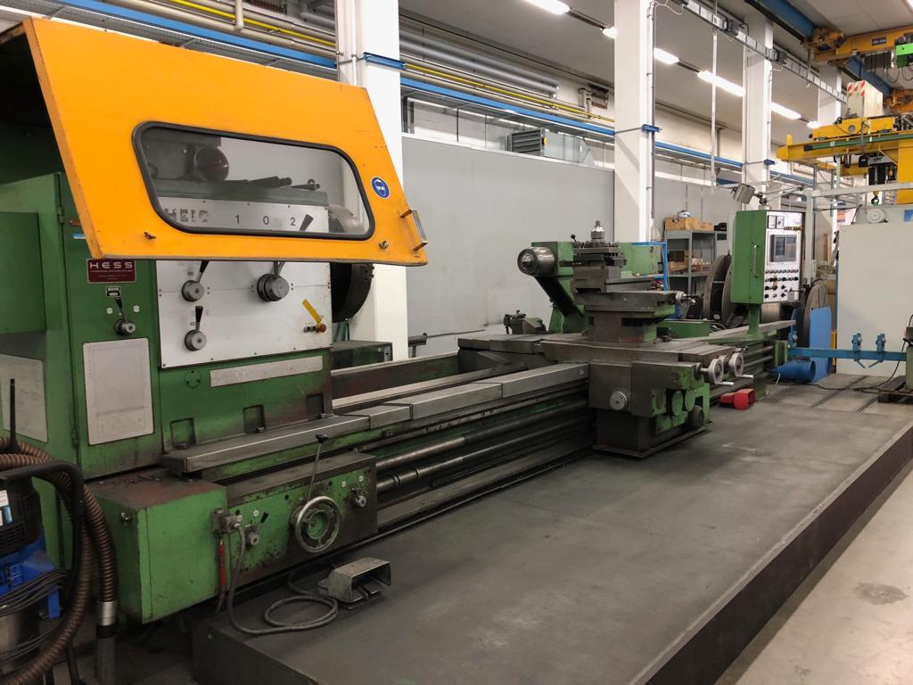
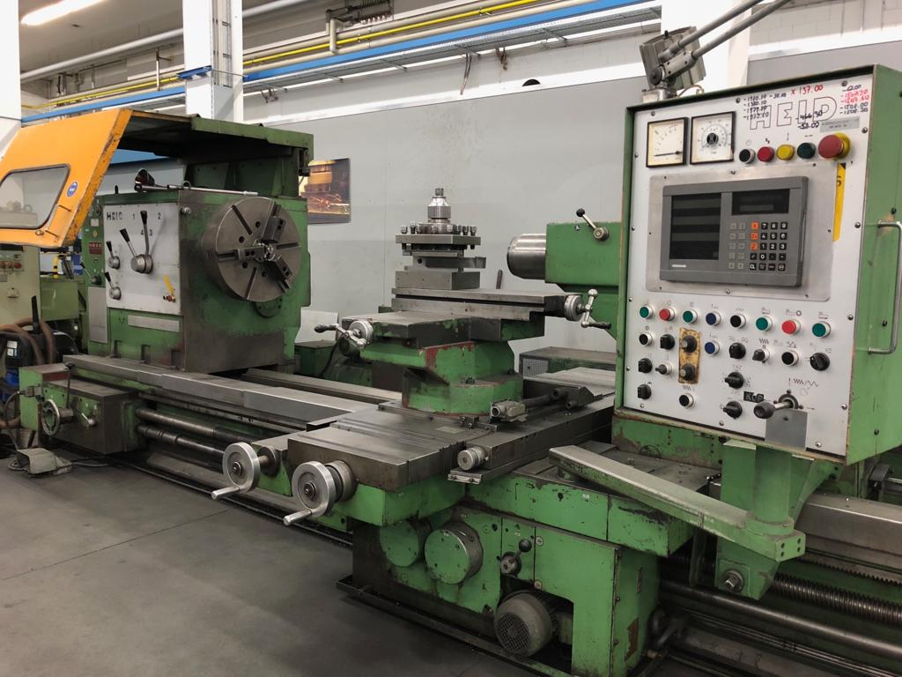
- Work load flying chuck : 2500
- Spindle bore : 150
- Bed width : 800
- Turning speeds 8 steps : 0 - 560 Rpm
- Tails tock Pinole Ø : 150
-Pinole stroke : 300
- Taper tail stock : Metric 80
- Dimensions
- Length : 8.000
- Width : 2.200
- Height : 2.100
- Weight : 16.500
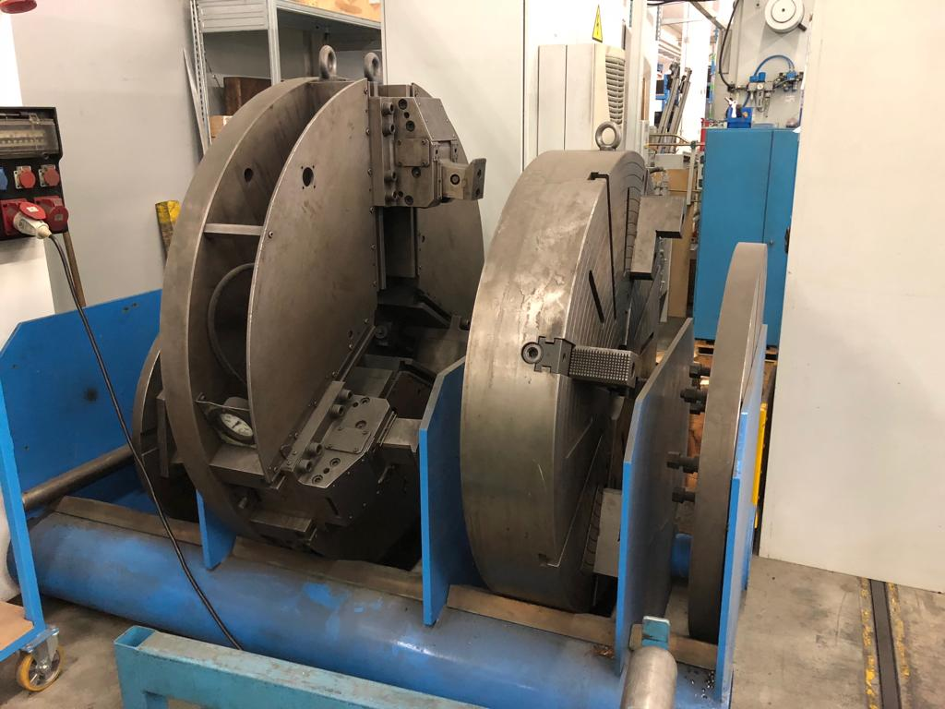

- incl. 4 chuck Ø
- incl. feeds all directions
- incl. HeidenHain digital readout

Please Note: The above information has been obtained to the best of our ability and belief from, and from the manufacturers where possible. It is given in good faith, but its accuracy can not be guaranteed. Accordingly, it will not form a representation or constitute contractual terms. We advise you to check any vital details!

